# Archi - ArchiMate Modelling



**What’s New in Archi Version 2.6**

# Important Note

It is always a good idea to make backup copies of your data before installing a new version of Archi. Whilst we make every effort to test the software and check for bugs we cannot guarantee that bugs do not exist in the application nor that your data might be affected by changes in this version of Archi.

Note - models created in Archi version 2.6 cannot be opened in previous versions of Archi.

## New Features in version 2.6

* Can now set line colour of diagram elements to user colour or derived from fill colour
* Added new user default colour preferences for line colours, group and note fill colours
* Improved Colours Preference page
* Preferences Panes rationalised
* ArchiMate Relationships matrix moved from Preferences to a dialog accessible from Help menu
* Improved functionality for saving user default colours in the model file
* Improved Format Painter - can copy between connections and objects
* Improved controls in Property | Appearance section
* Connection bend-points can now snap to grid (provided by Jean-Baptiste Sarrodie)
* Connections can now use rounded curves (provided by Jean-Baptiste Sarrodie)
* Connections can now use line jumps (provided by Jean-Baptiste Sarrodie)
* Improved connection anchors on some figures (rounded rectangles)
* Relationship rules have been updated to comply with ArchiMate 2.1 (provided by Jean-Baptiste Sarrodie)
* Added "Check for New Version" menu item to Help menu
* Can now add custom Jasper Reports to "reports" folder in Archi user directory (provided by Jean-Baptiste Sarrodie)
* New Jasper Report "Customizable Report" added (provided by Jean-Baptiste Sarrodie)
* New Template for "Customizable Report" added (provided by Jean-Baptiste Sarrodie)

# Review of the Main New Features

## Can now set line colour of diagram elements to user colour or derived from fill colour

There is now an option to set whether to set the line colour (borders) of elements or to derive the line colour from the element's colour. This is set in Preferences:

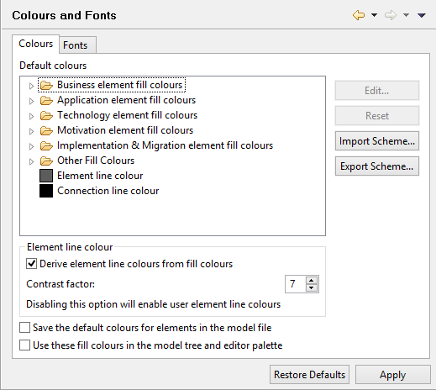

*Colours Preferences*

**Derive element line colours from fill colours**  
If this is checked a diagram element's line colour is derived as a darker shade of its fill colour. You can adjust the amount of contrast with the "Contrast factor" control. If this option is set, user line colours are ignored.

## Added new user default colour preferences for line colours, group and note fill colours and Improved Colours Preference page

In the Colours Preferences page (pictured above) you can now set the default colours for element lines, Groups and Notes (under the "Other Fill Colours" tree node).

The Colours Preferences Page has been greatly simplified and improved.

## Preferences Panes rationalised

All Preference Panes have been rationalised and improved. Please refer to the User Guide for full explanations of all Preferences.

## ArchiMate Relationships matrix moved from Preferences to a dialog accessible from Help menu

The ArchiMate Relationships matrix detailing all valid ArchiMate 2.1 relations is now available from the "Help | ArchiMate Relationships" menu as a separate dialog window. These are read-only and for informational purposes only.

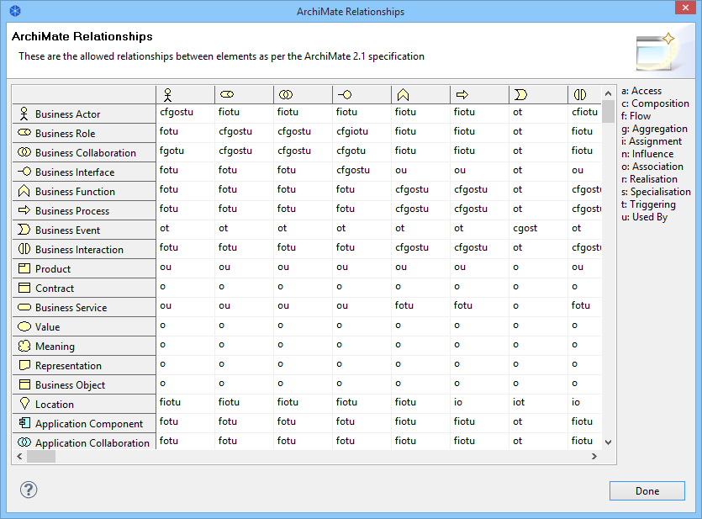

*Relationships matrix*

## Improved controls in Property | Appearance section

Controls are improved and simplified:

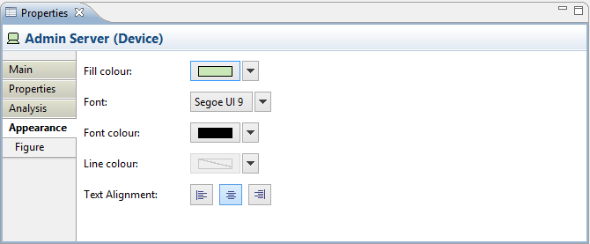

*Editing the "Appearance" Properties for an ArchiMate Element in a View*

## Connection bend-points can now snap to grid (provided by Jean-Baptiste Sarrodie)

Connection bend points can now snap to the grid, just like elements. This has been a long-requested feature.

## Connections can now use rounded curves and Connections can now use line jumps (provided by Jean-Baptiste Sarrodie)

There are now preferences to use rounded curves and line jumps for connection bend points:

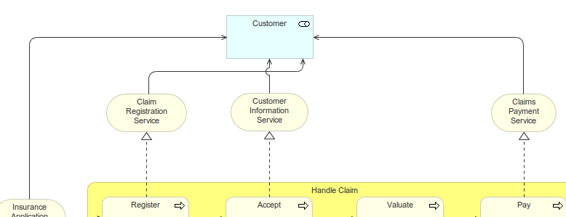

## Can now add custom Jasper Reports to "reports" folder in Archi user directory (provided by Jean-Baptiste Sarrodie)

If you create a "reports" folder in the Archi application data folder ("C:\Users\username\Application Data\uk.ac.bolton\Archi" on Windows) you can add your own custom Jasper reports here. These will appear in the Jasper Report wizard dialog.

## New Jasper Report "Customizable Report" and New Template for "Customizable Report" added (provided by Jean-Baptiste Sarrodie)

There is now a new Jasper "Customizable Report" in the export to Jasper dialog:

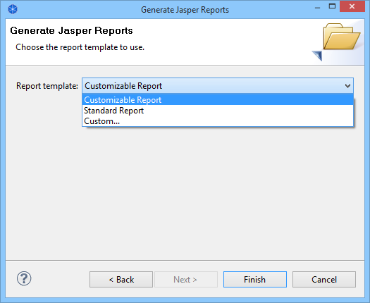

This can be configured according to various Properties set in the "Properties" for a model or its elements.

There is also a " Customizable Report " model template available that details how you can set these properties.

